Splat Fighters
Unity 3D Third-Person Paint Shooter Prototype
Technical Design and Implementation Guide

Course Project Documentation
Engine: Unity 2022.3 LTS
Render Pipeline: URP
Input: New Input System
Generated: 2026-04-23

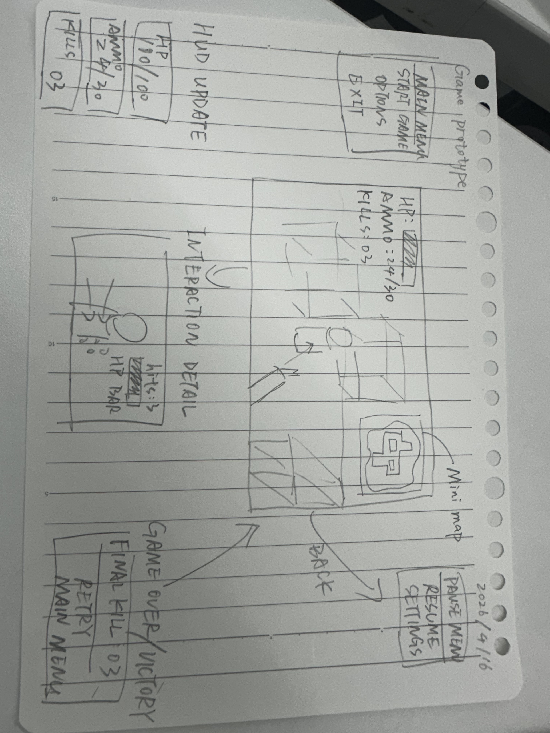
Concept reference image for the paint shooter prototype.

Document Contents
- Project overview and MVP scope
- Recommended Unity folder structure
- Scene setup and required objects
- Core systems and script responsibilities
- Grid-based painting and scoring system
- Testing workflow and development milestones
- Common risks and future expansion points

1. Project Overview
Splat Fighters is a student-friendly Unity 3D prototype inspired by territory-control paint shooters. The goal is not to recreate a commercial game. The goal is to build a playable, demonstrable, and explainable MVP that focuses on movement, aiming, shooting, ground painting, team scoring, and basic single-player opposition.
- Platform: PC prototype for course demonstration.
- Camera: third-person perspective.
- Core loop: move, aim, shoot, paint ground, score territory, finish match.
- Networking: out of scope for MVP.
- Transformation or swimming mechanics: out of scope for MVP.
- Painting scope: ground-only rectangular paintable areas first.

2. MVP Scope
Feature | MVP Requirement | Notes
Third-person movement | Player moves with camera-relative input. | Use CharacterController for a clear student implementation.
Aiming | Camera center ray defines target point. | Keep aiming stable before adding advanced reticles.
Shooting | Weapon fires ink projectiles or raycast impacts. | Projectile can be added after grid painting is verified.
Ground painting | A hit world position paints cells in a circular radius. | Uses grid ownership data, not texture pixels.
Team scoring | TeamA and TeamB coverage percentages are calculated from cell counts. | Unpainted cells remain part of the denominator.
Bot support | A simple bot can move and shoot using the same weapon path. | AI can start as a placeholder.
UI | Show timer, TeamA coverage, TeamB coverage, and match result. | HUD can read values from PaintManager.

3. Recommended Folder Structure
Assets/
Scenes/
Scripts/
Core/
Player/
Weapons/
Painting/
AI/
UI/
Utilities/
Prefabs/
Player/
Bot/
Weapons/
UI/
Materials/
Teams/
Paint/
Environment/
ScriptableObjects/
Teams/
Weapons/
Input/
Art/
Audio/
Docs/
The current implementation places the ground painting and scoring scripts under Assets/Scripts/Painting. This keeps the most important technical system isolated from player movement, weapons, AI, and UI.

4. Required Scene Objects
Scene Object | Components | Purpose
PaintManager | PaintManager | Global entry point for painting calls and total coverage scoring.
PaintableGround | MeshRenderer, Collider, PaintableArea | Defines the rectangular paintable grid area.
Player | CharacterController, input reader, movement, aiming, weapon scripts | Controlled third-person character.
Bot | CharacterController or NavMeshAgent, BotController, InkWeapon | Single-player opponent or placeholder AI.
Main Camera | Camera follow or Cinemachine camera | Provides view direction and aiming ray.
Canvas | UIManager and HUD widgets | Displays score, timer, crosshair, and result.
Lighting | Directional Light and URP environment settings | Basic readable scene presentation.

5. Core Script Inventory
Script | Type | Attach To | Responsibility
Team.cs | Enum | No scene object | Defines Team.None, Team.TeamA, and Team.TeamB.
PaintGridCell.cs | Serializable data class | Not attached directly | Stores the current owner of one grid cell.
PaintableArea.cs | MonoBehaviour | PaintableGround | Owns the grid, paints cells in a radius, provides cell counts, and draws debug Gizmos.
PaintManager.cs | MonoBehaviour singleton | PaintManager object | Finds paintable areas, routes paint calls, and reports total coverage.
PlayerInputReader.cs | MonoBehaviour | Player | Reads New Input System actions and exposes input state.
PlayerController.cs | MonoBehaviour | Player | Handles third-person movement.
AimController.cs | MonoBehaviour | Player or camera rig | Finds aim point from camera center ray.
InkWeapon.cs | MonoBehaviour | Player and Bot | Controls fire rate, projectile spawn, team ownership, and paint radius.
InkProjectile.cs | MonoBehaviour | Projectile prefab | Moves, detects impact, and calls PaintManager.PaintAtWorldPosition.
UIManager.cs | MonoBehaviour | Canvas | Displays timer, score, and match result.
BotController.cs | MonoBehaviour | Bot | Runs simple movement and shooting behavior for MVP.

6. Painting and Scoring System

6.1 Why Use a Grid
- It is deterministic: every cell has exactly one owner.
- It is easy to debug: Gizmos can draw each painted cell in the Scene view.
- It is easy to score: coverage is just owned cell count divided by total cell count.
- It avoids advanced shader, UV, decal, and render texture work during MVP development.
- It is suitable for a course project because the algorithm is simple to explain in a presentation.

6.2 Data and Visual Separation
The painting system separates gameplay data from visual presentation. PaintableArea stores cell ownership and score counts. Gizmos are only a debug visualization. A later PaintVisualizer can read the same grid data and render it using colored tiles, a dynamic Texture2D, mesh vertex colors, or URP decals.

6.3 Main Public API
// Paint cells in a world-space radius.
int PaintAtWorldPosition(Vector3 worldPosition, float radius, Team team);
// Get coverage percentage for one team.
float GetCoveragePercent(Team team);
// Get raw owned cell count for one team.
int GetCellCount(Team team);
// Clear all painted cells.
void ClearPaint();

6.4 Painting Flow
- A projectile or test tool provides a world-space hit position.
- PaintManager checks registered PaintableArea objects.
- The matching PaintableArea converts the world position into local XZ coordinates.
- The local coordinate is converted into grid indices.
- All cells whose centers fall inside the paint radius are assigned to the firing team.
- Team cell counters are updated immediately when ownership changes.
- Coverage percentages can be queried by UI or match logic.

7. Current Implemented Files
File | Current Status
Assets/Scripts/Painting/Team.cs | Implemented. Defines the team enum used by painting and scoring.
Assets/Scripts/Painting/PaintGridCell.cs | Implemented. Data-only cell owner storage.
Assets/Scripts/Painting/PaintableArea.cs | Implemented. Grid creation, painting, counts, coverage, hit lookup, and Gizmos.
Assets/Scripts/Painting/PaintManager.cs | Implemented. Singleton access, area registration, paint routing, total score queries, and clear-all tool.

8. Setup Instructions
- Create an empty GameObject named PaintManager and add the PaintManager component.
- Create a ground object named PaintableGround. A scaled cube or plane is enough for the first test.
- Add a Collider to PaintableGround so projectiles or raycasts can hit it later.
- Add PaintableArea to PaintableGround.
- Set Area Size to match the playable ground dimensions, for example 20 by 20.
- Set Grid Width and Grid Height to 50 by 50 for a readable first debug pass.
- Select PaintableGround in the Scene view and use the component context menu to run Debug Paint Center / Team A.
- Use Debug Paint Center / Team B to verify overwriting behavior.
- Use Clear Paint to reset the grid.

9. First Test Checklist
- Gizmos are enabled in the Scene view.
- PaintableGround is selected if Draw Only When Selected is enabled.
- Debug Paint Center / Team A creates blue cells around the center.
- Debug Paint Center / Team B creates orange cells around the center and can overwrite TeamA cells.
- GetCoveragePercent(Team.TeamA) and GetCoveragePercent(Team.TeamB) return non-zero values after painting.
- PaintManager.Refresh Paintable Areas finds the PaintableGround object.
- PaintManager.Clear All Paint resets all registered areas.

10. Development Milestones
Milestone | Goal | Deliverables
Week 1 | Core prototype loop starts working. | Third-person movement, camera aiming, basic shooting, grid painting visible in Scene view.
Week 2 | Playable match loop. | Two teams, score UI, match timer, result screen, simple bot that can paint.
Week 3 | Presentation polish. | Basic effects, sound, improved visual paint layer, restart flow, code comments, debug tools, final demo scene.

11. Common Risks
- Starting with realistic arbitrary-surface paint can consume the entire project schedule.
- Mixing scoring with visual materials makes bugs harder to diagnose.
- Very high grid resolution can slow down Gizmo drawing and future visual updates.
- Fast physical projectiles can miss collisions unless continuous collision detection or raycast checks are used.
- Bot AI should remain simple until the player, weapon, and painting systems are stable.

12. Future Extensions
- Add a PaintVisualizer that turns grid data into colored tile meshes or a dynamic Texture2D.
- Add different weapon types with different radius, fire rate, projectile speed, and spread.
- Add bot strategies such as targeting unpainted cells or overwriting enemy territory.
- Add more map objects while keeping MVP painting ground-only.
- Add score bars, match timer, result panel, and restart button.
- Upgrade visual paint edges with noise masks, decals, particles, and impact effects.

13. Presentation Talking Points
- The project uses grid ownership as the authoritative gameplay data for painting and scoring.
- World-space hit positions are converted to local grid coordinates on the paintable area.
- Painting is radius-based and updates only cells inside the hit circle.
- Score is calculated from TeamA and TeamB cell counts, so it is stable and explainable.
- Visuals are separated from data, which allows the prototype to evolve without rewriting scoring logic.

End of Document

